# **Receipt Utility (Receipt Utility.exe)**

This application will allow you to interact with various printer service functions.

## **Usage**

After clicking “Receipt Utility.exe” you will be presented with the following options:

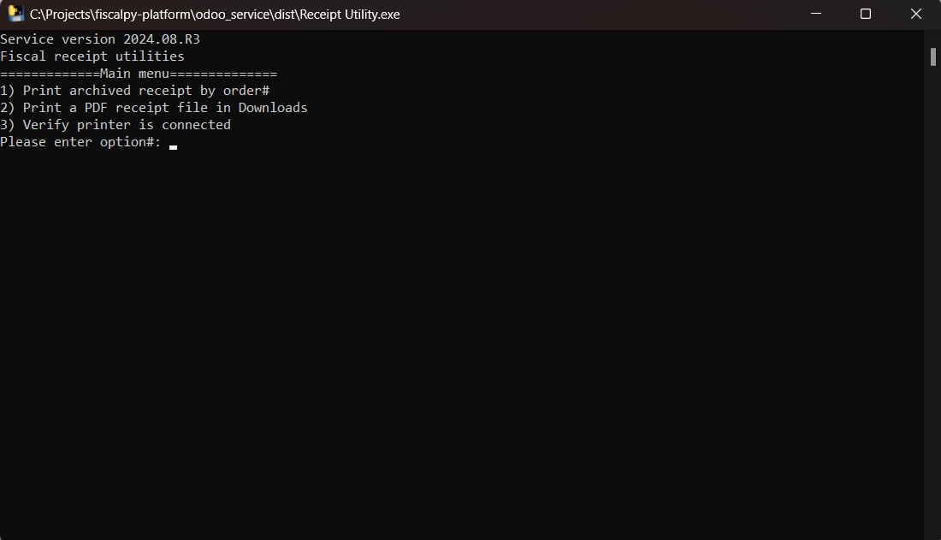

Ensure that you read the presented options carefully and enter the appropriate key using your keyboard.

### **Printing an archived receipt**

Use this utility function to print receipts which were Archived by the Receipt PDF service.

### 

This feature is useful in Scenarios where:

1. The Fiscal Printer was offline while the PDF Receipt service was running.
2. The Fiscal Printer had a technical glitch and is back online

**Note:** Use this with caution and certainty that the receipt was not already printed. Otherwise you may incur a tax deduction

## **Printing a PDF receipt file**

Use this utility function to manually print a supported PDF receipt file by following the prompts below:

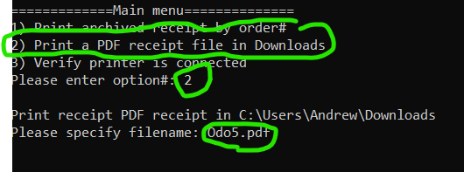

Use this feature to manually print a PDF file from the Downloads folder.

This feature is useful in scenarios where:

1. Receipt PDF Service wasn’t able to detect receipt pdf file
2. Receipt PDF Service was offline
3. Receipt PDF service is not working properly

## **Testing Printer Connectivity**

Use this utility to verify if the printer is connected to your computer. The test sends a sound signal to the connected printer and take note if the printer responds

